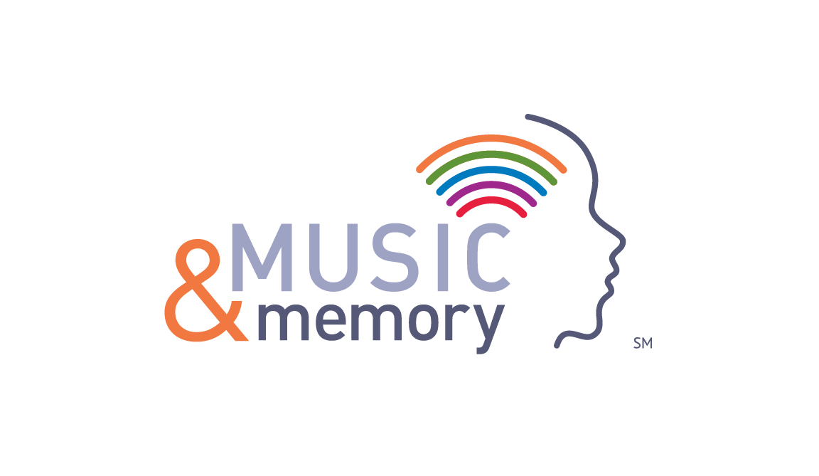
We are pleased to inform you that Pinnacle Ridge Nursing and Rehabilitation is now a Certified MUSIC & MEMORYSM Facility.
What is Music and MemorySM?
Music and MemorySM is a program where residents listen to personalized music playlists, created with input from residents themselves as well as family, friends and our staff. These playlists are loaded onto MP3 players so residents can connect with the music they love, with the goal of improving their overall health and well-being.
What are the anticipated benefits?
- Reduction in the reliance of anti-psychotic and anti-anxiety medications,
- Reduced agitation and sun downing
- Enhanced engagement and socialization with family, friends, staff and peers
- Increased cooperation and attention resulting in reduction of resistance to care
- Opportunity to offer an enjoyable, and fulfilling a need for a very personal activity.

Thank you so much.
If you have questions, please contact:
Matt Nutter, CTRS
Recreational Therapist
Pinnacle Ridge Nursing and Rehabilitation
(913) 782-3350
For more information, please visit
www.musicandmemory.org

