**Instructions on Music Devices**

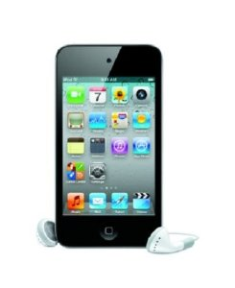

**Ipod Touch**

**On/off:**

1. To Turn on, press down on button on top of device.
2. To Turn Off, hold button at top down till device pops up with slide bar to power down.

**How to get to music:**

1. Slide the unlock bar on screen.
2. Push Music button at bottom of screen.
3. Push playlist at bottom of screen.
4. Click on person’s name.
5. Press shuffle.
6. If music does not start hit play button on the bottom of screen.

**Adjust Volume:**

1. Button on the left of device controls volume.
2. Click top of button for louder, bottom of button for softer.

**Charging:**

1. Plug cord into the bottom of iPod in slot.

2. Battery picture will show up on screen.

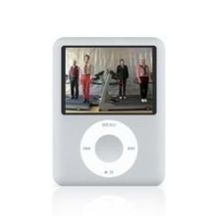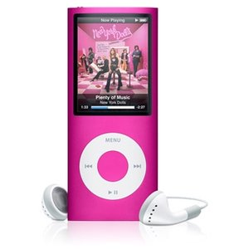

**Ipod Nano**

**On/Off:**

1. To turn on: Button at top of device switch Hold to off.
2. Screen will light up after hold switch is off.
3. To turn off: Hold down play button till screen goes black.
4. Switch button at top of device to Hold.

**How to get to music:**

1. Menu will pop up automatically.
2. Click Middle button when music is highlighted on screen.
3. Click middle button when playlist is highlighted on screen.
4. Click middle button when person’s name is highlighted on screen.
5. Click middle button on song you want when highlighted on screen.
6. Click play on bottom, music will start playing.

**Adjust Volume:**

1. When music is playing, roll your finger from the left to right on the top (past menu button) to make louder, for softer volume roll finger right to left on top.

**Charging:**

1. Plug charger into Bottom of iPod.
2. Battery will show charging on the screen.

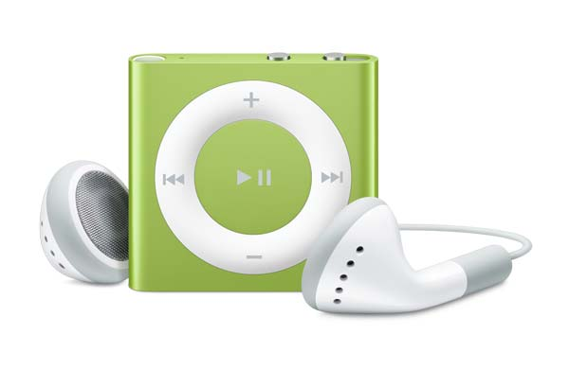

**IPod Shuffle**

**On/Off:**

1. To turn on slide button on top right to the left (Green will appear when slid to the right). Light will come on.
2. To turn off slide button on the right to the right (Green will disappear)

**How to get to music:**

1. After IPod is on, music will automatically start playing.
2. To switch songs hit left or right arrow keys.

**Adjust Volume:**

1. To make louder click the plus button, to soften the music press the negative button.

**Charging:**

1. Plug charger into top of iPod.
2. Light next to charger will come on.
3. Charging Light Indicates:

Green: Battery is full

Orange: Battery is below half full

Red: Battery is low

Blinking red: Battery is at 1%.

None: No battery life.

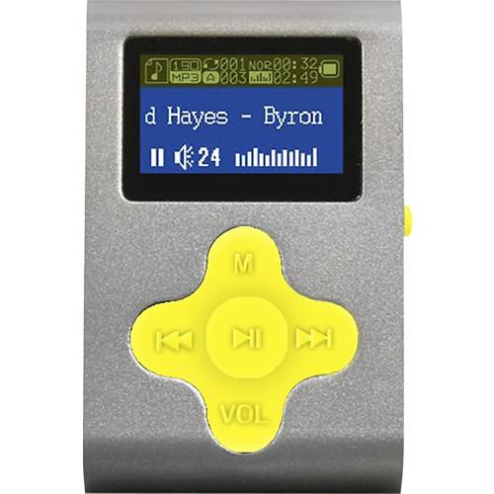

**Eclipse MP3**

**On/Off:**

1. On/Off swith on the right of device.
2. Flip switch either to On/Off.

**How to get to music:**

1. Click on M (Top arrow button).
2. Click play button (Middle button on arrow pad).
3. Click play button again to start music.
4. To switch music, click either right or left arrows on arrow pad.

**Adjust Volume:**

1. Make sure music is playing.
2. Click on VOL button (bottom of arrow pad).
3. Speaker button will be lighted up.
4. Click left arrow for softer, and right arrow for louder (You will see volume number go up or down on the right of speaker).

**Charging:**

1. Turn MP3 On. (switch on right side)
2. Plug charger into slot of the Left Side

3. Battery picture will show up.